COVID-19 doesn’t care who you are, but the pandemic does
Written by Gloria Gutman, Ph.D., Brian de Vries, Ph.D., Robert Beringer, DSocSci., Helena Daudt, Ph.D., & Paneet Gill, BSc.

COVID-19 Experiences & Advance Care Planning (ACP) among Older Canadians: Influence of Age Group, Gender, & Sexual Orientation Report to be released on January 29, 2021 at www.sfu.ca/lgbteol

Aim
We conducted a national survey of Canadians age 55+ to learn if some sub-groups are coping with the pandemic better than others and about its impact on daily life and future care planning. The aim is to empower programs and policies with evidence that can lead to a better quality of life during and after current and future pandemics.

Context
COVID-19 poses the greatest risk to older adults, in particular those with pre-existing medical conditions. Little, however, is known about how COVID-19 may be affecting sub-groups within the older population. Are some coping better than others? Has it stimulated some more than others to think about their future care needs and preferences? We asked these questions as part of an online survey conducted from August 10-October 10, 2020. 4380 Canadians aged 55+ told us about their current physical and mental health and lifestyle, and actions and discussions about future health care they’ve had, compared to before the COVID-19 pandemic began.

Key findings
- Contrary to expectations, those between the ages of 55 and 64 are experiencing more detrimental effects of the pandemic than those over 65. They are also less likely to follow COVID-19 public health recommendations.
- Women experience more COVID-19 related stress than men, even though they are more likely to follow public health recommendations.
- Lesbian, Gay and Bisexual (LGB) older adults are taking the virus and public health recommendations more seriously than heterosexuals.
- LGB older adults are more likely to have completed ACP documents and to have had discussions regarding future care

Conclusions and recommendations
- Attention needs to be drawn to the unique stresses experienced by the 55-64 age group.
- A public education campaign on virus safety measures targeting places commonly frequented by younger older adults (e.g. gyms, restaurants, bars, transit stations, workplaces), may be useful to increase compliance.
- A media campaign to promote COVID-safe physical activities may reduce the health burden of sedentary behaviour.
- LGB respondents who have had previous pandemic experience should be encouraged and supported to reach out to their community and beyond with stories of survival and resilience.
- Given the unpredictability of life that COVID-19 has highlighted, encourage Canadians to plan ahead. Even as 60% of our sample had completed a will, all other ACP documents were completed by only 18% to 40%.

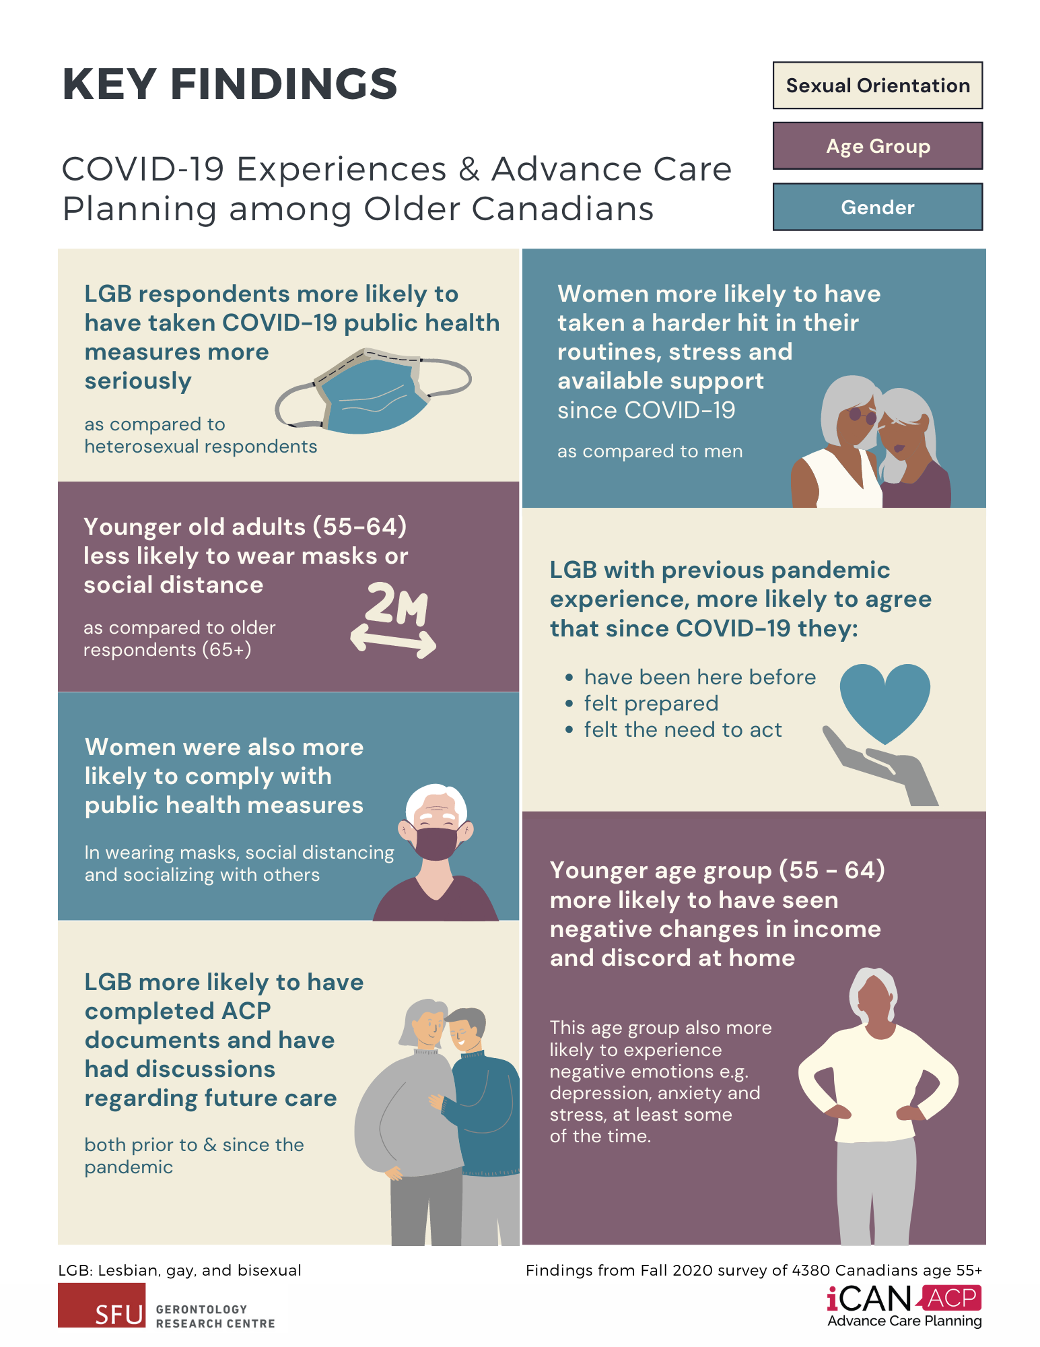

Acknowledgements
This research is funded by Canadian Frailty Network (Technology Evaluation in the Elderly Network), which is supported by the Government of Canada through the Networks of Centres of Excellence (NCE) program.
For further information please contact Dr. Gloria Gutman, Diversity Access Team Lead, Simon Fraser University Gerontology Research Centre, at gutman@sfu.ca or 604-263-5221.

